**Name:** Rana Tarek Abd-El-Halim Mohamed Amara

**B.N:** 351

**Edu. mail**: [Rana195387@feng.bu.edu.eg](mailto:Rana195387@feng.bu.edu.eg)

**Topic:** Artificial Intelligence

**Github-link:** <https://github.com/ranatarek-rt/html-project-repository>

**Application brief:**

Technology has revolutionized our world and daily life over the years, it has created wonderful tools and services to bring valuable knowledge to our fingertips. Modern technology has paved the way for multi-functional devices such as the smartwatch and smartphone. Computers are getting faster, more portable and more powerful than ever before. Technology has also made our lives easier, faster, better and more fun with all those revolutions. So mainly technology became a part of our life that’s why I choose artificial intelligence to talk about.

**Artificial intelligence:** Artificial intelligence is when machines can learn and make decisions in the same way as humans. There are many forms of artificial intelligence, including machine learning, where computers can observe, interpret and learn from data and mistakes as our human brains do, instead of being programmed what to do.

**Some Applications on artificial intelligence:** Over the past decade, AI has begun delivering results, especially with the recent rapid progress in machine learning and increased data and computing power availability.

**AI in banking:** Many banks have already implemented AI-based systems for providing service to customers, detecting irregularities and credit card fraud. HDFC Bank is one such example, the use of AI for fraud prevention is not a new concept. In fact, AI solutions can be used to enhance security across a number of business sectors, including retail and finance.

**Life-saving AI in healthcare:** Artificial intelligence isn't just improving lives, in some cases it can save lives. Many organizations, including tech firms, are investing in and exploring ways that artificial intelligence can help develop our healthcare system. From the identification of personalized drug protocols to better diagnostic tools and even robots for operations.

**Source code**

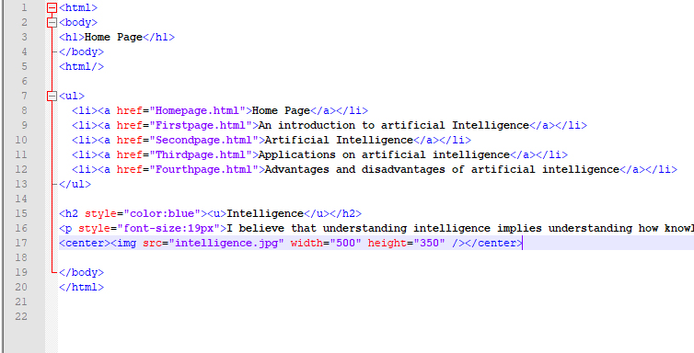

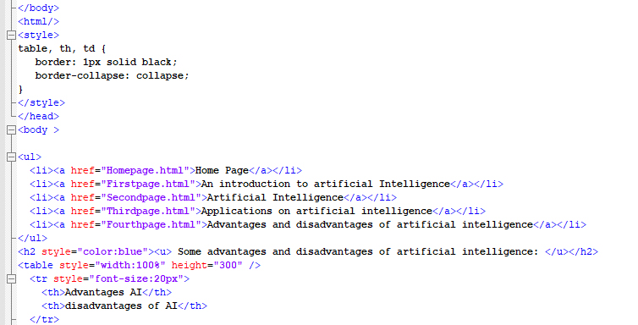

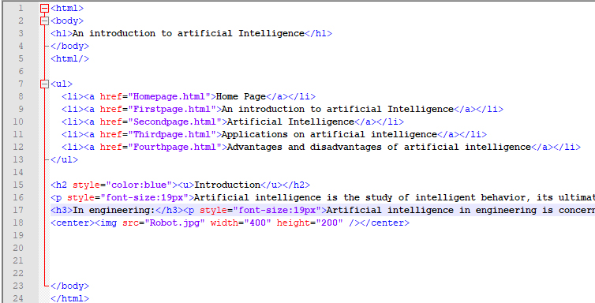

**Screenshots**

